# PROJECT REPORT TEMPLATE

# 1 INTRODUCTION

* 1. **OVERVIEW**

* **In this project, we use custom objects, relationships, page layouts to give the HR team easy access to data they need on existing recruitment app.**
* **To make the existing app more efficient for the HR team we create custom objects and relationships to store and access the data more effectively. We install an unmanaged package in the org to get metadata that acts as existing data in the recruitment app.**

* 1. **PURPOSE**

**Salesforce helps businesses keep track of customer interactions and sales data. It can manage leads, contacts, opportunities, and cases. Salesforce also offers several features to help businesses automate their sales and marketing processes, such a email marketing, lead capture, and lead scoring.**

# PROBLEM DEFINITION & DESIGN THINKING

**2.1 EMPATHY MAP**

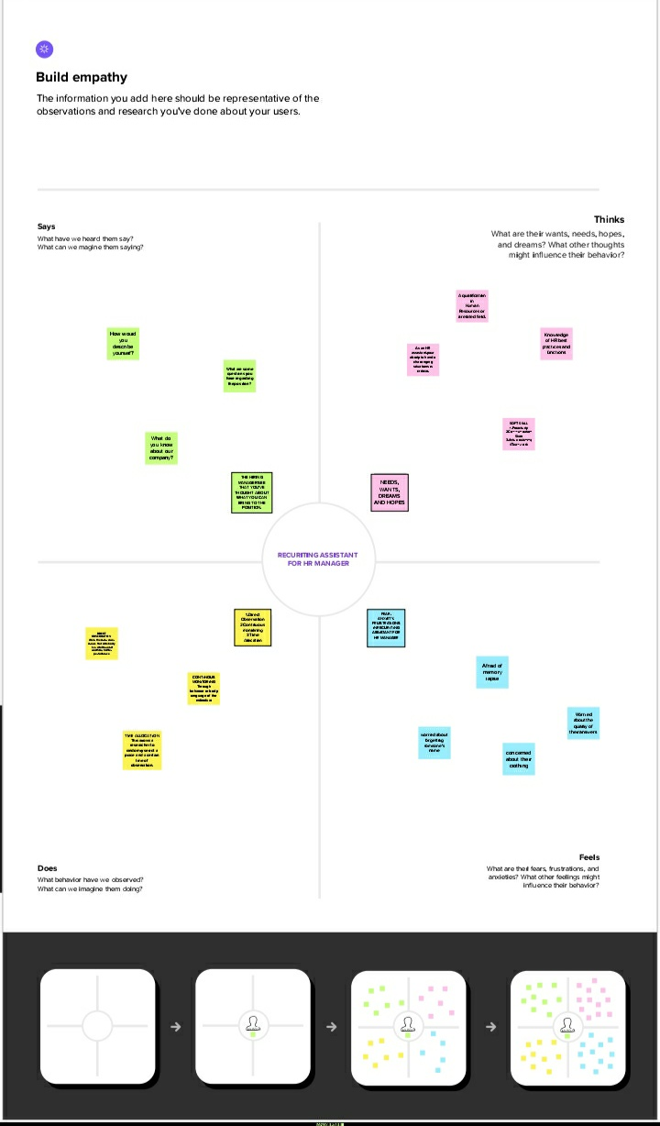

**2.2 IDEATION & BRAINSTORMING MAP SCREENSHOT**

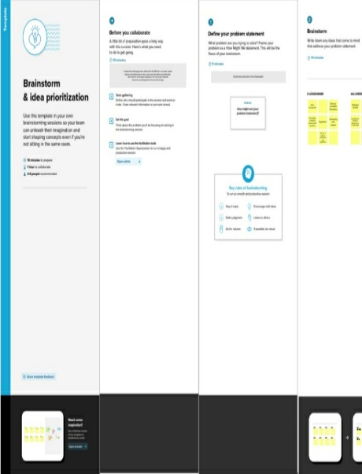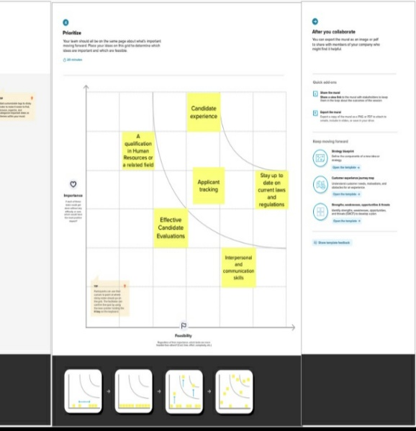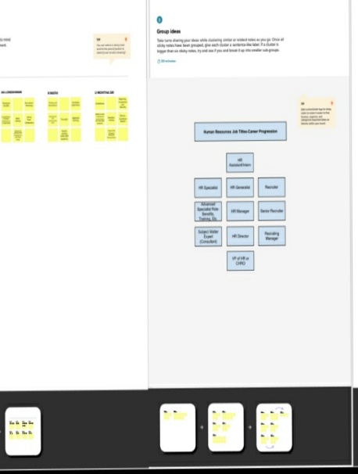

# RESULT

**3.1 DATA MODEL**

|  |  |
| --- | --- |
| **Object name** | **Fields in the object** |
| **Obj 1** | |  |  | | --- | --- | | Field label | Data type | | job application | custom object | | job applications | custom object | |
| **Obj 2** | |  |  | | --- | --- | | Field label | Data type | | Position | custom object | | Positions | custom object | |

**3.2 ACTIVITY & SCREENSHOT**

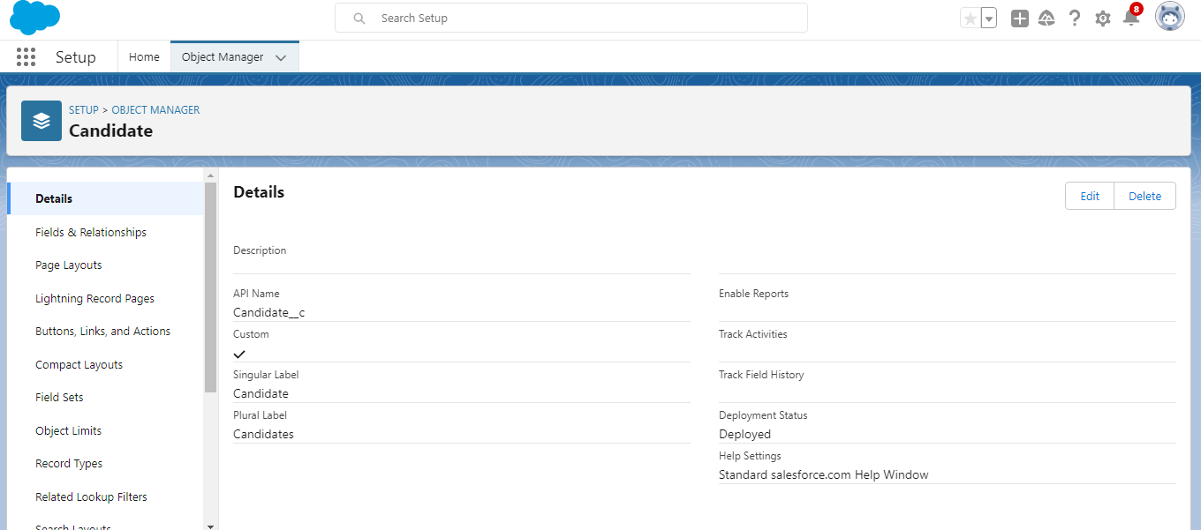

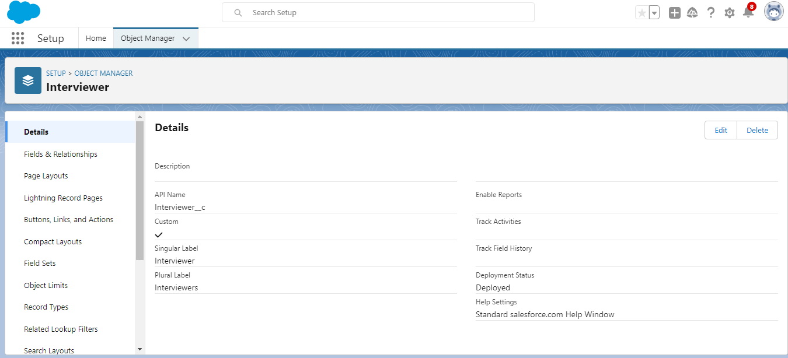

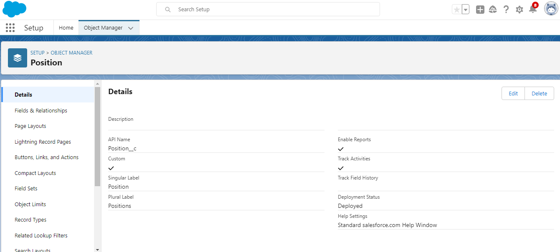

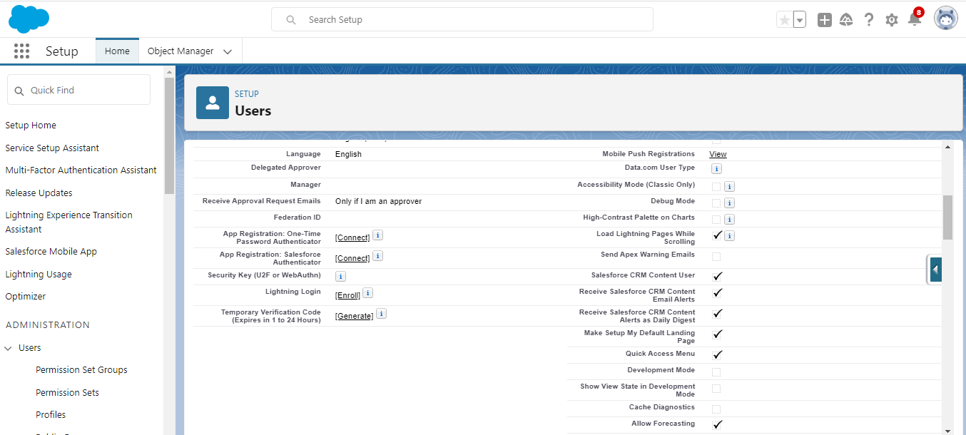

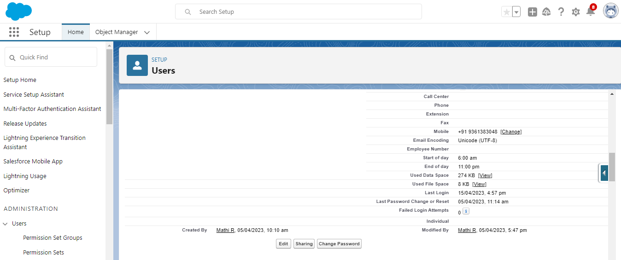

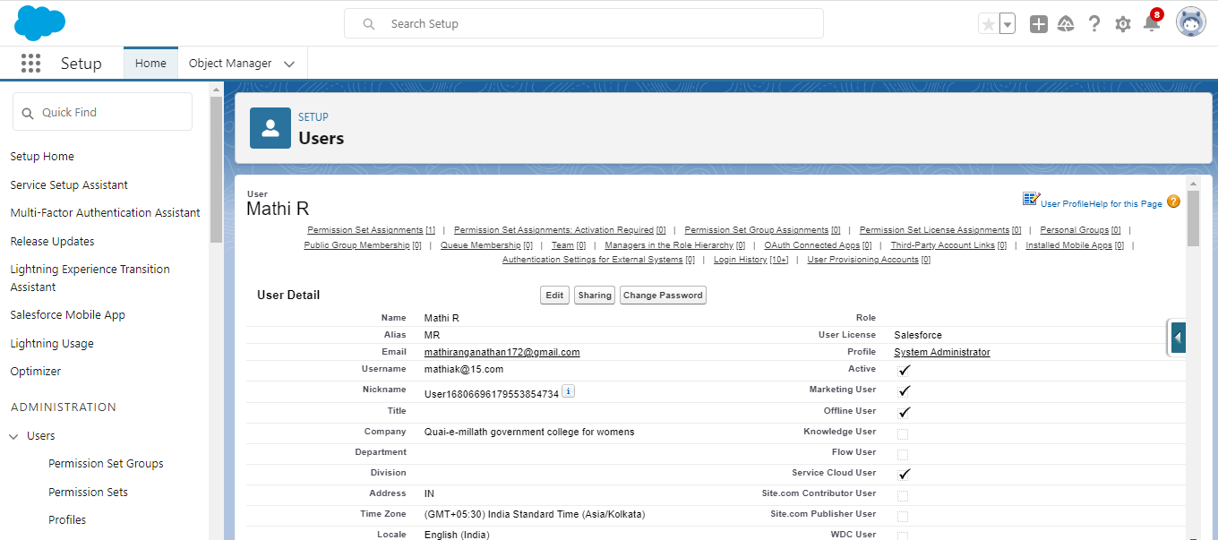

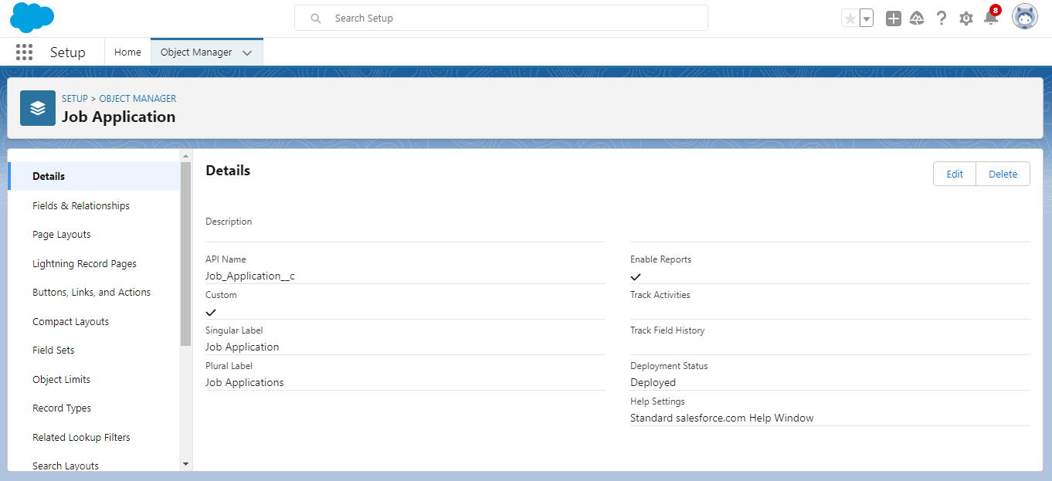

# TRAILHEAD PROFILE PUBLIC URL

Team Lead- <https://trailblazer.me/id/llokeshwari>

Team Member 1- <https://trailblazer.me/id/loke14>

Team Member 2- <https://trailblazer.me/id/mathiak1517>

Team Member 3- <https://trailblazer.me/id/movithasri>

# ADVANTAGES & DISADVANTAGES

**Advantages**

**Salesforce is helping companies reap the benefits of automated workflows and processes. It also helps to achieve better customer service, customer relationship and brand building, customer retention, and higher returns on marketing investments(ROMI)**

**Disadvantages**

**There are also a number of disadvantages associated with the application of the sales force automation at the workplace. Sales force automation can lead to inadequate communication between departments. This occurs when the system is not well integrated and interconnected with the rest of the departments in the same company.**

# APPLICATIONS

**Salesforce helps HR manager the employee experience while delivering the tools employees need to collaborate, work smarter, and experiment at speed. Our customers get dedicated support from our help desks, and self-service training on Trailhead**.

# CONCLUSION

**The performance of the project team was rated A by the management team. Every team contributed actively during the project execution phase.12 milestones were set at the beginning of the project. The first 6 milestones were achieved before the targeted date while the last 6 milestones where achieved after the targeted date. A total of 7 high issues and 10 low issues were noted all were treated during the project period. At the end, there was no open issues. Through the support of the project and risk management the project did not exceed the budgeted cost.**

# FUTURE SCOPE

**Demand for salesforce developers will skyrocket in 2023, and the manufacturing and banking sectors are the two that are growing fastest. That being said, a salesforce developer’s job is extremely broad. These individuals can deal with a variety of tasks; for example: venture applications, online stores, and CRMs**